**Right Click on the downloaded folder named “Project”**

**And select Extract here.**

**All the folders will be extracted to the current location.**

**Now copy the folders as mentioned below.**

**Installing java**

Copy the “ j2sdk1.4.2_04 “ folder to **C:\Program Files\**

Enter ***sysdm.cpl* in the run command.**

**Select the Advanced tab and select Environment Variables.**

**Select NEW button**

**Variable Name : path**

**Variable Value: C:\Program Files\j2sdk1.4.2_04\bin;**

**Click ok.**

**Again click NEW button.**

**Variable Name : lib**

**Variable Value : C:\Program Files\j2sdk1.4.2_04\lib;,;**

**Click ok.**

**Click Apply.**

**Enter cmd in the run command .**

**Enter javac in the command prompt.**

**Java is successfully installed.**

**Automatic Admission Software**

Copy Backend and Frontend folders to any local drive.

Eg : C:\\Program Files\backend

C:\\Program Files\frontend

**Creating a DSN(Data Source Name)**

Go to control Panel

Double click Administrative tools

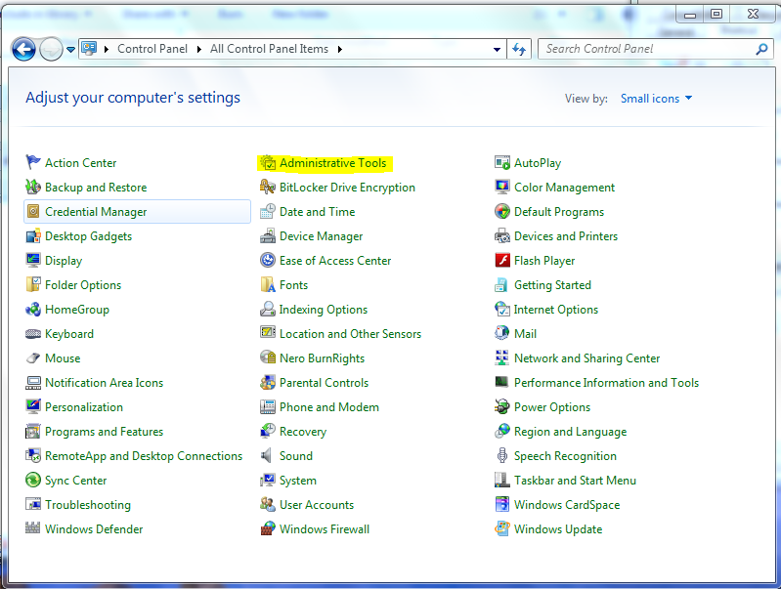

Select ODBC ( Data Source Name)

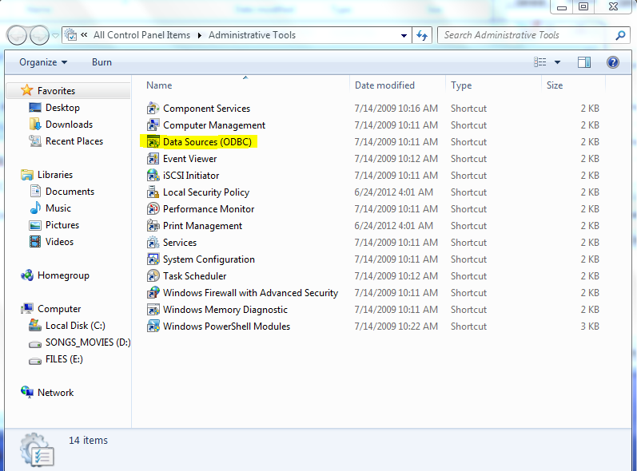

Click the Add button

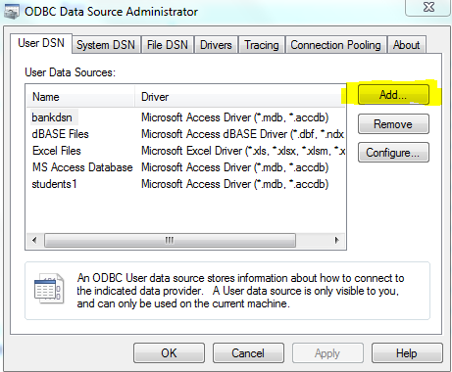

Select the Microsoft Access Database Driver (accdb)

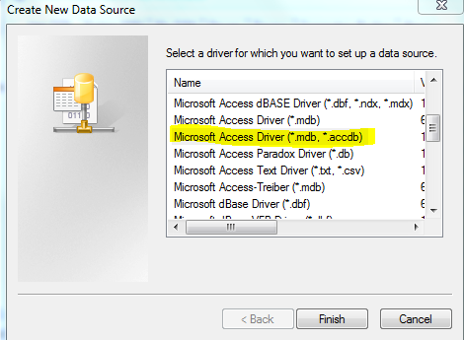

Enter the Data Source name as “students1”

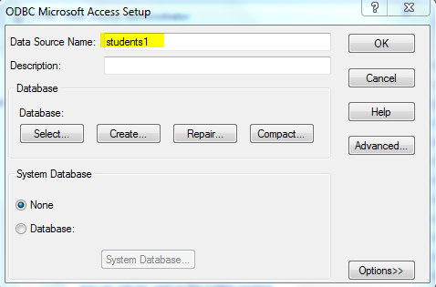

Click the Select button

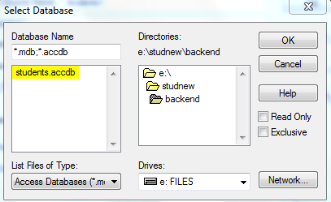

Select the backend folder (Eg: C:\\Program Files\Backend\)

Select the “students.accdb” file.

Click OK button to save.

Now the DSN is successfully created.

**Next is creating shortcuts to run the Software**

Right click on the desktop, New ->Shortcut and select the C:\studnew\frontend\frontend.bat and save it as Students.

Right click on the desktop, New ->Shortcut and select the C:\studnew\backend\backend.bat. and save it as Administrator.

Right click on the shortcuts created and select Properties and select Minimized in the Run of the Shortcut tab.

Now the Software is successfully installed.